A Guide for Using Zoom in the Classroom

Before Class
- Schedule your Zoom meeting (recurring meeting recommended for weekly class sessions).
- Send the meeting link to students.
Option 1: Schedule at Zoom.us
- From zoom.us go to Meetings.
- Schedule the meeting.
- Copy the invitation.
- Add the meeting link to Canvas (homepage, modules, announcement, message, etc.) and/or send via email.
Option 2: Schedule using the Zoom tool in Canvas
- Access your Canvas course.
- Add Zoom to the course menu from Settings > Navigation.
- Click Save.
- Click Zoom from the course menu.
- Schedule the meeting.
- Students will access the meeting link from the Zoom area in Canvas.

On the Day of Class
- Plug in your laptop or turn on the computer in the classroom.

- Plug in your microphone, web camera, or any additional equipment.
  - Make sure the microphone isn’t muted.

- Turn on the projector.

- Start the Zoom meeting from Zoom.us or from the Zoom tool in Canvas.
- In Zoom test the speaker and microphone.
  - Click the arrow next to mute/unmute.
  - Select Test Speaker & Microphone.
  - If no audio, then change speaker to Conexant,
Extron, or try all of them.

- Open PowerPoint or the documents that you will be showing during class.
  - In PowerPoint, you can begin Slideshow Mode.
- Begin Screen sharing.
  - Return to Zoom. > Click Share Screen. > Select Screen, Screen 1, or Screen 2.
  - To share the document camera, click Share Screen > Click Advanced > Click Content from 2nd Camera.
  - To share audio from a video, check the box to share computer sound.
- As students join, ask them to test their microphone and speakers.

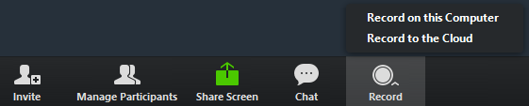
- Start the Recording.
  - Record to the cloud provides a sharable link and download options.
  - Record on this computer will download to the computer. Then you will need to upload the video to Google Drive or YouTube to share it.
- Return to PowerPoint to advance the slides or navigate to other applications you are sharing.
  - Keep an eye out for raised hand or chats in Zoom.

- At the end of class stop the recording, stop screen sharing, and end the meeting.
  - Tips: You may have to exit minimized view. Look on projector to end screen sharing or try Windows Key + P to display on the PC screen only.
  - You will receive an email when the cloud recoding is ready. Due to unusually high volume during the COVID-19 pandemic, cloud recordings may require extra processing time.

After Class
Share the recording with students.
Option 2: If you Scheduled using the Zoom Tool in Canvas
- Access your Canvas course.
- Click Zoom from the course menu.
- Click the Cloud Recordings Tab.
- Click Publish.
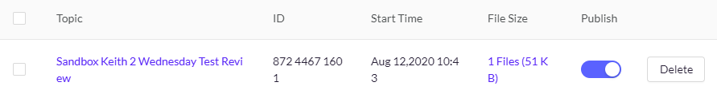
Option 1: If you Scheduled at Zoom.us
- From zoom.us go to Recordings.
- Click Share.
- Copy to clipboard.
- Paste the recording link in Canvas (modules, announcement, message, etc.)

Video Cart Options
- Turn on the video cart. Turn on the laptop. Then, use the two remotes to turn on the tv screen and web camera.
- Connect the laptop to WiFi if it isn’t already. (SFU-Secure and login with your SFU username)
- Sign into Zoom on the video cart if you plan to host the meeting from that device or use join meeting and enter the numbers for your meeting room.
- If hosting click Start Meeting. Test speakers, microphone, and web camera.
- Start the recording.
- Stop the recording and end the meeting.
Advanced Video Cart Options
- Sign into from your own laptop or the podium computer. Start the meeting. Then mute the speakers and microphone on this computer. Begin screen sharing such as displaying a PowerPoint.
- From the Video cart, open zoom and click join meeting. Enter the meeting ID number. Use the microphone and speaker from this device to broadcast sound.

